Abdirizak Abdullahi

1 - usestaticarray:

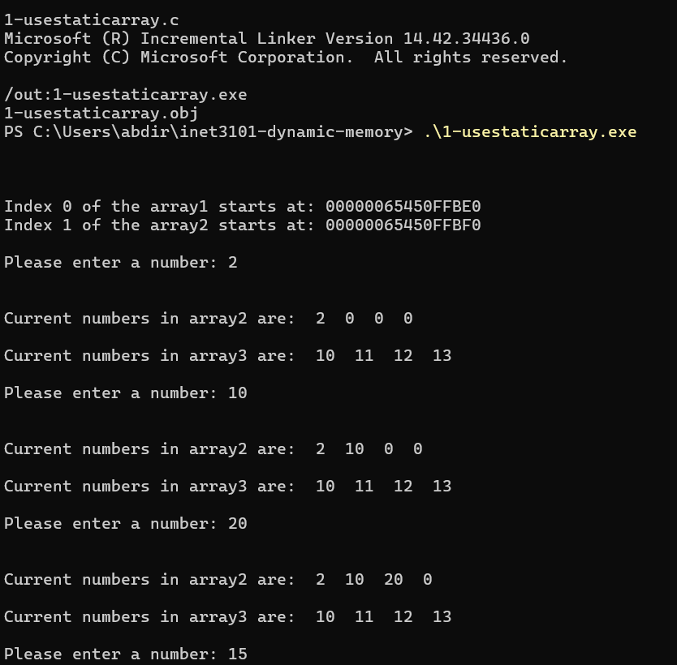

3-dynamically allocation:

The program starts by asking the user how many numbers they want to enter and makes space on the memory for that amount. Then it keeps asking the user to enter numbers in a while loop. If the user enters more numbers than the original limit, the program increases the array size using realloc, that doubles the memory so it can hold more numbers. The program won’t run out of space, and the user can keep adding as many numbers as they want. It also checks if realloc works properly to avoid any issues. This method makes sure the program runs smoothly without wasting a lot of memory.

4-simple dynamic example:

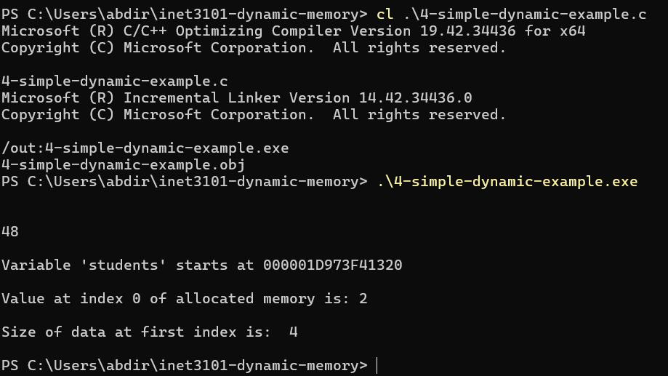

5-python lists are objects

### What’s an Object in Object Oriented Programming

An object in OOP is like a object that holds both data (attributes) and actions (methods) together in one place. Objects are created from something called a class which is basically a blueprint. This makes programming more organized and easier to look at because you can just reuse objects and your code more orderly.

### How a Python List Shows the OOP Concept

C has arrays, which are just simple memory storage, a list in Python is much more advanced than that. It comes from the built in list class, which means it has both data (the actual stuff in the list) and functions that let you work with it easily.

Python lists handle things like memory and resizing automatically. You don’t have to worry about managing memory like in C. Python just does it on its own. so you can just use the list without thinking about how it works behind the scenes.

6- linked list

Using a linked list makes it easier to manage memory because you can add or remove items without worrying about running out of space. In a regular array if you need more space than you originally set, you’ll probably have to create a new and bigger array and copy everything over. A linked list avoids this problem by dynamically moving memory and spacing it for your needs.